JavaTM 2 Enterprise Edition

XML API for JavaTM Transactions

JSR 156

Specification Lead:
Mark Little
Hewlett-Packard

Technical comments:

Version 0.2
Expert Group Draft
Trademarks
Java, J2EE, Enterprise JavaBeans, JDBC, Java Naming and Directory Interface are trade-marks or registered trademarks of Sun Microsystems, Inc. in the U.S. and other countries.
Table of Contents
1. Introduction 5
1.1 Scope 6
1.2 Target Audience 6
1.3 Organization 6
1.4 Document Convention 7
1.5 J2EE Activity Service Expert Group 7
1.6 Acknowledgements 9
2. Overview 11
2.1 When ACID is too strong 12
2.2 Extended transactions 13
2.3 Plugable transactionality 15
2.4 The invocation protocol 17
3. JAXTX architecture 19
3.1 The components and their roles 21
3.1.1 The XML context 21
3.1.2 The Web Service 22
3.1.3 The participant 23
3.1.4 The coordinator 23
3.2 The interfaces and protocols 24
3.2.1 Protocols 24
3.2.2 Interfaces 24
3.3 Combining implementations 25
3.4 XML configuration 25
3.4.1 Transaction configuration schema 26
4. JAXTX components 29
4.1 Features 29
4.1.1 Client interaction interface 29
4.1.2 Extended client interfaces 29
Coordinator interface 30
4.1.4 Participant interface 30
Context management 30
4.2 Core JAXTX packages 31
4.2.1 javax.jaxtx package 31
4.3 Model bindings 38
4.3.1 The Business Transactions Protocol 38
5. Transaction framework protocol 43
5.1.1 Qualifiers 44
5.1.2 Protocol messages 45
5.1.3 More on context 47
5.1.4 Coordinator 49
5.1.5 Participant 49
6. References 52

Introduction
This document describes the system design and interfaces for XML based transactions. JAXTX is the realization, within the J2EE programming model, of work that has been conducted in various commercial, academic, and standards organizations into enabling Web Services with the critical transactional capabilities that they need.
An increasingly large number of distributed applications are constructed by being composed from existing applications. The resulting applications can be very complex in structure, with complex relationships between their constituent applications. Furthermore, the execution of such an application may take a long time to complete, and may contain long periods of inactivity, often due to the constituent applications requiring user interactions. In a loosely coupled environment like the Web, it is inevitable that long running applications will require support for fault-tolerance, because machines may fail or services may be moved or withdrawn. A common technique for fault-tolerance is through the use of atomic transactions, which have the well know ACID properties, operating on persistent (long-lived) objects. Transactions ensure that only consistent state changes take place despite concurrent access and failures.
Traditional transaction processing systems are sufficient if an application function can be represented as a single top-level transaction. Frequently this is not the case. Top-level transactions are most suitably viewed as “short-lived” entities, performing stable state changes to the system; they are less well suited for structuring “long-lived” application functions (e.g., running for minutes, hours, days, …). Long-lived top-level transactions may reduce the concurrency in the system to an unacceptable level by holding on to resources (e.g., locks) for a long time; further, if such a transaction aborts, much valuable work already performed could be undone.
As has been shown elsewhere [ref] there are a number of transaction models, each suited to different types of applications and services. The J2EE Activity Service work of JSR 95 is intended to support the development of these models and others. However, it does not concentrate on how these implementations can be exposed as Web Services and interacted with via SOAP and XML. Alternatively, some implementations of Web Services transactions already exist, e.g., BTP [ref] and provide solutions for the specific problem domains. Other models will undoubtedly be developed to solve different application requirements. In addition, although ACID transactions may not be the solution for all transactional Web Service applications, it is likely that some applications will continue to require strict ACID semantics. Therefore, existing implementations of JTA/JTS may well require a Web Services persona.
The purpose of JAXTX is to identify the common components within (traditional and extended) transaction systems and provide a standard set of interfaces to these components. Importantly, JAXTX interfaces do not imply a specific implementation for the underlying transaction system to which they talk. This is to allow a single set of interfaces to interact with a wide range of implementations. It is the purpose of this specification to enable existing XML-based transaction implementations to be integrated with JAXTX without requiring them to be modified. However, this specification also provides optional protocol definitions to allow new implementations to be defined entirely within the context of JAXTX.
Note, in the rest of this document we shall use the term ACID transaction to refer to traditional transaction functionality as presented by, for example, JTA [ref]. The terms transaction or extended transaction, shall refer to models that give different functionality to ACID transactions, for example by relaxing various aspects of the ACID properties.

Scope
This document and related javadoc describes the architecture, functionality and interfaces that must be provided by an implementation of JAXTX in order to support XML transactions.
Specific implementations of transaction services (e.g., JTA or BTP) will be able to use the interfaces defined by JAXTX to provide a uniform and standard API for their use.

Target Audience
The target audience of this specification includes:
- implementers of transaction services (e.g., JTA or BTP) who wish to make their components available as Web Services.
- implementers of application servers and EJB containers.
- implementers of Web Services that require some level of transactionality.

Organization
This document describes the architecture of JAXTX with its components and roles described.
Specific interfaces are described in general terms in this document and in more detail in the accompanying javadoc package.

Document Convention
A regular Times New Roman font is used for describing the architecture.
A regular Courier font is used when referencing Java interfaces and methods on those interfaces.

J2EE Activity Service Expert Group
The expert group consists of the following members:
Mark Little, mark_little@hp.com
Hewlett-Packard,
Arjuna Labs,
Central Square South,
Orchard Street,
Newcastle upon Tyne,
NE1 3AZ,
UK
Michael Abbot, mike@codemetamorphosis.com
15 Berenda Way Suite 300,
Portola Valley, CA 94028,
USA
Rahul Bhargava, rahul_technical@yahoo.com
Netscape Communications,
MS MV-015,
465 Ellis Street,
Mtn View, CA 94043,
USA
Pyounguk Cho, pyounguk.cho@iona.com
IONA Technologies,
2350 Mission College Blvd.,
Suite 650,
Santa Clara, CA 95054,
USA
Alan Davies, adavies@seebeyond.com
SeeBeyond Technology Corporation,
404 E Huntington Drive,
Monrovia,
CA 91016,
USA
Keith Evans, keith.b.evans@hp.com
Hewlett-Packard/Compaq Computer Corporation,
CAC16-01, Room 162100,
10100 North Tantau Avenue,
Cupertino, CA 95014,
USA
Peter Furniss, peter.furniss@choreology.com
Choreology Ltd,
13 Austin Friars,
London, EC2N 2JX,
UK
Kavantzas Nickolaos, nkavantz@us.oracle.com
Oracle,
500 Oracle Parkway,
MS 4op9,
Redwood Shores, 94065,
USA
Bill Pope, zpope@pobox.com
PO Box 6698,
Portsmouth NH 03801,
USA
Ian Robinson, ian_robinson@uk.ibm.com
International Business Machines,
IBM Hursley Lab,
Hursley,
Winchester,
Hant, SO21 2JN,
UK
Anne Thomas, atm@systinet.com
Idoox,
1 Broadway,
14th Floor,
Cambridge, MA 02142,
USA

Peter Walker, Peter.Walker@sun.com
Sun Microsystems, Inc.
901 San Antonio Road
MS USCA14-303
Palo Alto, CA 94303

Acknowledgements

Overview
Business-to-business (B2B) interactions may be complex, involving many parties, spanning many different organisations, and potentially lasting for hours or days. For example, the process of ordering and delivering parts for a computer which may involve different suppliers, and may only be considered to have completed once the parts are delivered to their final destination. Unfortunately, for a number of reasons (not least of which are commercial) parties involved in B2B simply cannot afford to lock (reserve) their resources exclusively on behalf of an individual indefinitely, thus ruling out the use of atomic transactions for all applications.
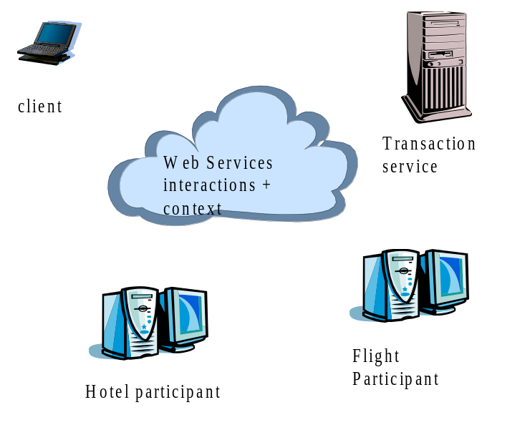
Figure 1: Web Services transaction actors.
In general a business transaction requires the capability for certain participants to be structured into a consensus group, such that all of the members in such a grouping agree to the same outcome. For example, consider the case shown in Figure 1, where a transaction is begun by the actions of a client to book a hotel room and a flight. Both of these actions are required or neither is, i.e., no partial outcome will be tolerated. The hotel and flight booking web services are therefore required to enrol respective participants with the transaction. When the client ends the transaction, the transaction service will ensure that both participants reach the same outcome such that either the hotel and flight are booked or neither operation occurs.
Importantly, different participants within the same business transaction may belong to different consensus groups. The business logic then controls how each group completes. In this way, a business transaction (driven, for example, by a workflow system) may cause a subset of the groups it uses to perform the work it asks, while asking the other groups to undo the work.

When ACID is too strong
To ensure atomicity between multiple participants, a multi-phase (typically two) consensus mechanism is required, as illustrated in Figure 2: during the first (preparation) phase, an individual participant must make durable any state changes that occurred during the scope of the atomic transaction, such that these changes can either be rolled back (undone) or committed later once consensus to the transaction outcome has been determined amongst all participants, i.e., any original state must not be lost at this point as the atomic transaction could still roll back. Assuming no failures occurred during the first phase (in which case all participants will be forced to undo their changes), in the second (commitment) phase participants may make the new replace the original state with the new durable state.
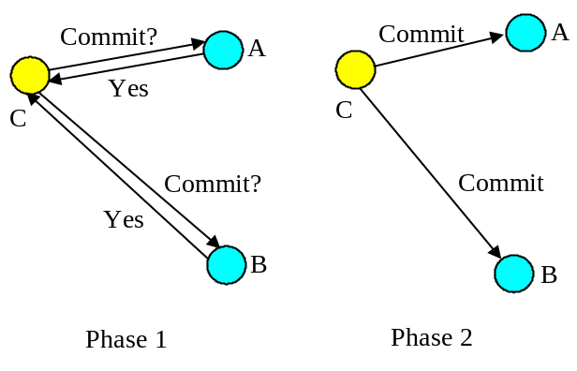
Figure 2: Two-phase commit protocol.
In order to guarantee consensus, two-phase commit is necessarily a blocking protocol: after returning the phase 1 response, each participant which returned a commit response must remain blocked until it has received the coordinator’s phase 2 message telling it what to do. Until they receive this message, any resources used by the participant are unavailable for use by other atomic transactions, since to do so may result in non-ACID behaviour. If the coordinator fails before delivery of the second phase message these resources remain blocked until it recovers. In addition, if a participant fails after phase 1, but before the coordinator can deliver its final commit decision, the atomic transaction cannot be completed until the participant recovers: all participants must see both phases of the commit protocol in order to guarantee ACID semantics. There is no implied time limit between a coordinator sending the first phase message of the commit protocol and it sending the second, commit phase message; there could be seconds or hours between them.

Extended transactions
Structuring certain activities from long-running atomic transactions can reduce the amount of concurrency within an application or (in the event of failures) require work to be performed again. For example, there are certain classes of application where it is known that resources acquired within an atomic transaction can be released “early”, rather than having to wait until it terminates; in the event of the atomic transaction rolling back, however, certain compensation activities may be necessary to restore the system to a consistent state. Such compensation activities (which may perform forward or backward recovery) will typically be application specific, may not be necessary at all, or may be more efficiently dealt with by the application.
For example long-running activities can be structured as many independent, short-duration top-level atomic transactions, to form a “logical” long-running transaction. This structuring allows an activity to acquire and use resources for only the required duration of this long-running activity. This is illustrated in Figure 3, where an application activity (shown by the dotted ellipse) has been split into many different, coordinated, short-duration top-level atomic transactions. Assume that the application activity is concerned with booking a taxi (t1), reserving a table at a restaurant (t2), reserving a seat at the theatre (t3), and then booking a room at a hotel (t4), and so on. If all of these operations were performed as a single atomic transaction then resources acquired during t1 would not be released until the top-level atomic transaction has terminated. If subsequent activities t2, t3 etc. do not require those resources, then they will be needlessly unavailable to other clients.
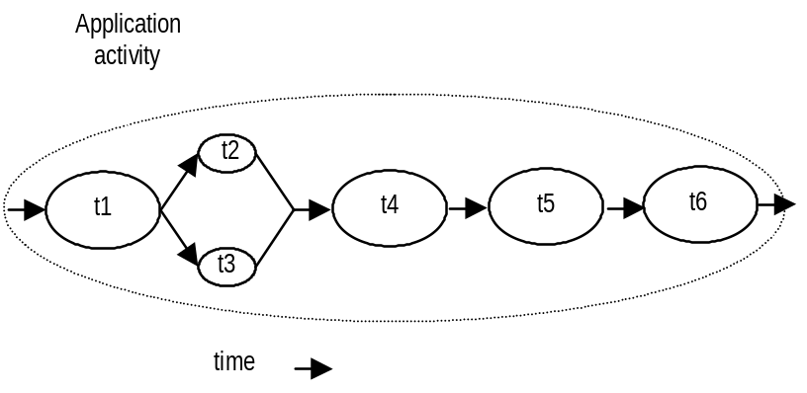
Figure 3: An example of a logical long-running “transaction”, without failure.
However, if failures and concurrent access occur during the lifetime of these individual transactional activities then the behaviour of the entire “logical long-running transaction” may not possess ACID properties. Therefore, some form of (application specific) compensation may be required to attempt to return the state of the system to consistency. A transactional workflow system can be used to provide scripting facilities for expressing the composition of these transactions with specific compensation activities where required. For example, let us assume that t4 aborts. Further assume that the application can continue to make forward progress, but in order to do so must now undo some state changes made prior to the start of t4 (by t1, t2 or t3). Therefore, new activities are started; tc1 which is a compensation activity that will attempt to undo state changes performed, by say t2, and t3 which will continue the application once tc1 has completed. tc5’ and tc6’ are new activities that continue after compensation, e.g., since it was not possible to reserve the theatre, restaurant and hotel, it is decided to book tickets at the cinema. Obviously other forms of composition are possible.
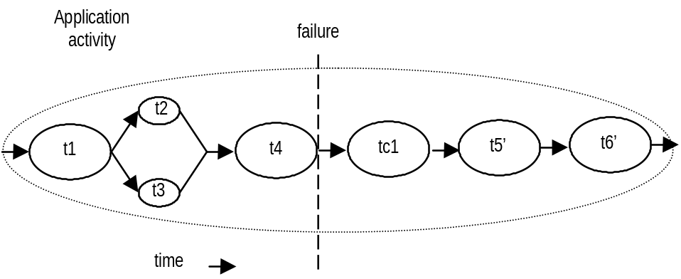
Figure 4: An example of a logical long-running “transaction”, with failure.
Much research on structuring applications out of transactions has been influenced by the ideas of spheres of control [5]. There are several ways in which some or all of the application requirements outlined above could be met [6][7][8][9][10].
- Independent top-level transactions: with this mechanism it is possible to invoke a top-level transaction from within another transaction [6][11]. If the invoking transaction rolls back, this does not lead to the automatic rollback of the invoked transaction, which can commit or rollback independently of its invoker, and hence release resources it acquires. Such transactions could be invoked either synchronously or asynchronously. In the event that the invoking transaction rolls back and compensation is required, compensating transactions may be invoked automatically by the transaction system or dealt with by the application.
- Glued transactions: long-running top-level transactions can be structured as many independent, short-duration top-level transactions, to form a “logical” long-running transaction; the duration between the end of one transaction and the beginning of another is not perceivable, and selective resources can be atomically passed from one transaction to the next [7]. This structuring allows an activity to acquire and use resources for only the required duration of this long-running transactional activity. In the event of failures, to obtain transactional semantics for the entire long-running transaction may require compensation transactions which can perform forward or backward recovery.
- Transactional workflows: a transactional workflow system can be used to provide scripting facilities for expressing the composition of an activity (a business process) out of other activities (which could be transactional), with specific compensation activities [8].
- Business transaction protocol: the OASIS Business Transaction Protocol [ref] introduced the notion of an open-top two-phase termination protocol. Work is conducted within the scope of atoms, which are similar to atomic transactions and have the same all-or-nothing guarantees. However, the outcome of atoms are controlled by cohesions which allow their selective confirmation or cancellation by explicitly driving the two-phase protocol over a period of hours, days etc.
From a user’s (client/service) perspective, differences in how extended transaction protocols are coordinated and controlled are typically minimal: the user starts the transactional activity, communicates with services and propagates information about the transaction (the context), and terminates the transaction. Most differences occur between the transaction controller (the coordinator) and its enlisted participants. For example, does it use a two-phase or three-phase termination protocol?

Plugable transactionality
What does it mean to a client to begin a BTP transaction, a JTA transaction, or a glued transaction, for example? In many cases the answer is very little, since much of the transactionality guarantees and semantic knowledge reside within and between the services and the coordinator with which the client interacts. Therefore, conceptually a single client implementation could interact with several different transaction services according to requirements placed on the application by: the services, the environment, the business needs, etc. In a Web Services environment, the services used by a client may be dynamically selected based upon the transaction model(s) they support (e.g., specified in UDDI) by a layer between the client and the actual service, explicitly by the business logic etc. At the level of the client/user all they are typically interested in is starting a transaction and performing work within its scope, leaving the actual transactional specific aspects to the services and the coordinator.
As a result, this specification aims to provide an interface to these different transaction protocols that allows different implementations to be plugged in. If necessary the user can introspect the underlying implementation to determine specific attributes and properties, but we believe that typically this will not be necessary. In addition, if specific models require enhanced interfaces in order to operate, these can be obtained in a structured and well defined manner.
JAXTX components allow the management in a Web services interaction of a number of activities or tasks related to an overall application. In particular JAXTX allows a user to:
- define demarcation points which specify the start and end points of transactional activities
- register participants for the activities that are associated with the application
- propagate transaction-specific information across the network
The main components involved in using and defining JAXTX are illustrated in Figure 5:
- A Transaction Service: Defines the behaviour for a specific transaction model. The Transaction Service provides a processing pattern (implemented by the transaction coordinator) that is used for outcome processing. For example, an ACID transaction service is one implementation that provides a two-phase protocol definition whose coordination sequence processing includes prepare, commit and rollback. Other examples of Transaction Service implementations include patterns such as Sagas, Collaborations, Nested or Real-Time transactions and non-transactional patterns such as Cohesions and Correlations [14]. Multiple Transaction Service implementations may co-exist within the same application and processing domain. JAXTX does not specify how a Transaction Service is implemented: one service may be tied to a specific protocol, or the service could support multiple different protocols as in [3].
- A Transaction API: Provides an interface for transaction demarcation and the registration of participants.
- A Participant: The operation or operations that are performed as part of the transaction coordination sequence. During the lifetime of a transaction a coordinator may send many different XML messages to a participant, which may perform specific units of work depending upon how it interprets these XML messages.
- The Context: this contains information necessary for services to use the transaction, e.g., enlist participants and scope work.
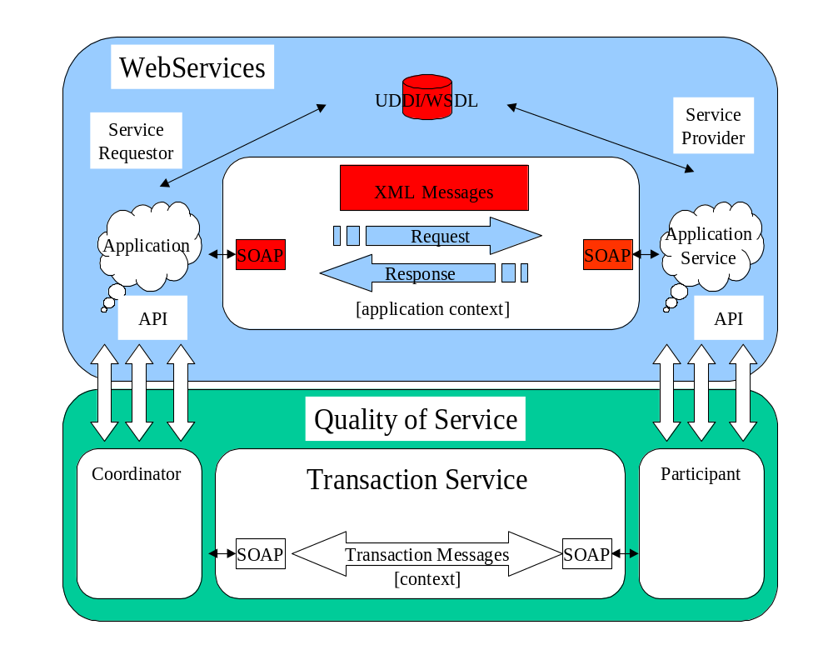
Figure 5: Web Services, transactions and contexts.
This specification does not provide a means whereby existing transaction service implementations can be provided to Web Services and their users via SOAP (for example) and XML, since it is assumed that this has been done elsewhere in other specifications. Neither is it meant to place additional requirements on such implementations (e.g., BTP). What JAXTX does accomplish is to allow these implementations to be plugged into a common services architecture. Note, however, that JAXTX does specify protocols for new transaction service implementations to use that will allow for their straightforward integration.
The appendices of this specification contain protocol specific information for Java Web Services transaction implementations that do not occur in other specifications. For example, a definition of how components of the JTA/JTS specifications may be incorporated into Web Services, allowing the implementation of ACID Web transactions and services.

The invocation protocol
We do not assume that a single remote invocation mechanism (e.g., SOAP) will be the natural communication medium for all Web Services. How participants within and between activities appear to each other is not central to this discussion. They may be CORBA objects, communicating via IIOP, or they may be coarser grained Web Services objects, communicating via SOAP, for example. We assume that they will use the most appropriate invocation protocol for the application, e.g., it is unlikely that there will be much real-time video streaming over SOAP/HTTP. This does not preclude a given application from using multiple object models and communication protocols simultaneously.
Furthermore, we assume that protocol negotiation will occur on many levels (e.g., which transaction models are supported by a Web Service and in use by the invoker, which communications protocols are provided, business level issues, etc.) We do not prescribe when (or even if) such negotiation occurs.

JAXTX architecture
A transaction is a unit of (distributed) work, involving one or more parties (services, components, objects). A transaction is created, made to run, and then completed. An outcome is the result of a completed transaction and this can be used to determine subsequent flow of control to other transactions. Transactions may run over long periods of time (minutes, hours, days, …) and can thus be suspended and then resumed later.
A very high level view of the role of JAXTX within a Web Service architecture is shown in Figure 6. The transaction coordination service is responsible for managing transactions created by the client. Work performed by the client may be executed under the scope of a transaction such that the coordinator will ensure that the work performed in some manner consistent with the underlying transaction model (e.g., that it either happens or does not despite failures).
When a client performs an invocation on a service such that the work is required to be transactional, the client (or the infrastructure in which it is located) must flow information about the transaction (the context) to the service. The service is then responsible for ensuring that the work is performed in such a way that any final outcome is controlled by the transaction coordinator. This normally occurs by enlisting a participant in the transaction that has control over the work, e.g., an XAResource that can issue prepare, commit or rollback on a database when instructed to by the coordinator.
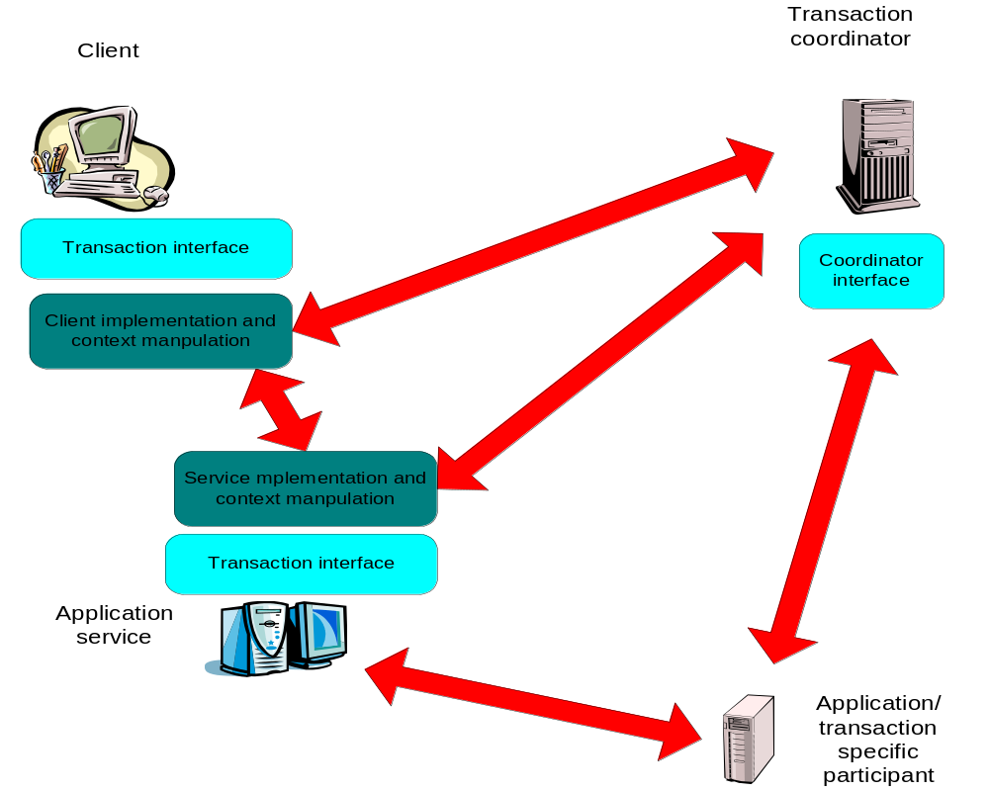

Figure 6: Applications and implementation components.
It is envisioned that in most situations the client/service protocol implementation (essentially the interactions shown) and context manipulation are already provided by existing standards and systems. For example, the OASIS Business Transactions Protocol defines precisely how the transaction context appears in transmitted XML documents, how coordinator specific messages are formatted, how participants behave under certain failure circumstances etc. However, the language interfaces to these components (e.g., the coordinator interface) may not be defined in their specifications at all. JAXTX provides a uniform set of interfaces for Java that are intended to indirect to the underlying implementations.
In other circumstances, it is possible that no appropriate transaction protocol currently exists in the Web services domain. As such, one of the goals of JAXTX is to support the development of these new protocols. Therefore, this specification provides optional protocols (including XML schemas) that designers can use in order to simplify their work and ease of integration within this framework.

The components and their roles
Before describing the interfaces which JAXTX provides, we shall first examine the components within a JAXTX architecture, as shown in Figure 7.
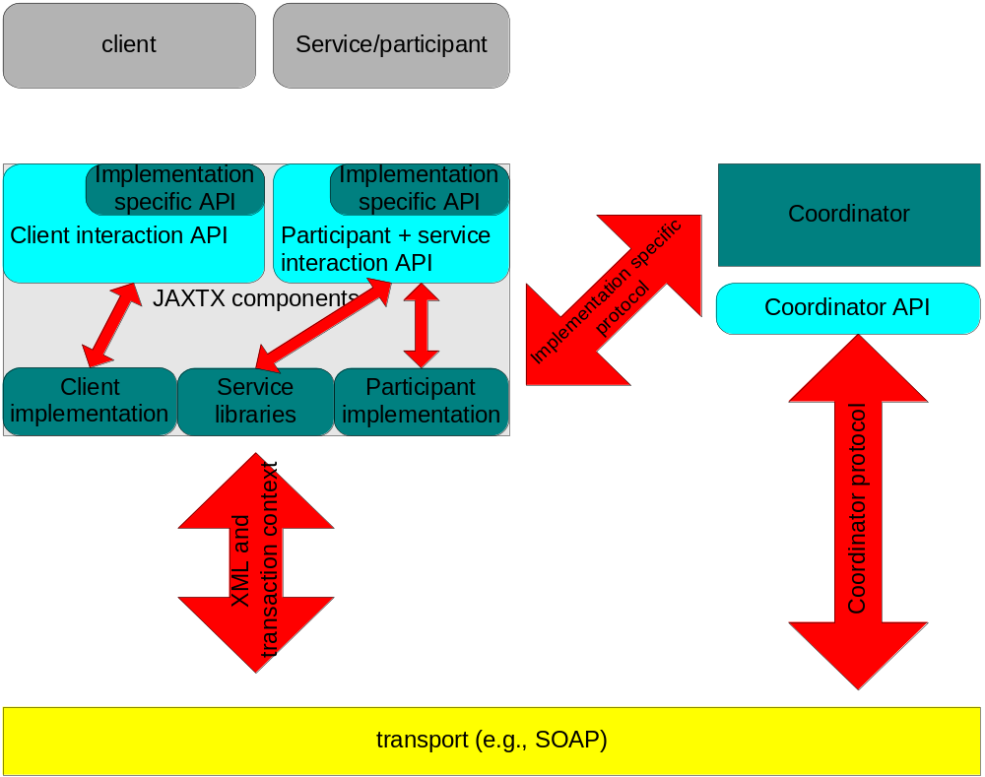
Figure 7: JAXTX architecture.

The XML context
In order for a transaction to span a distributed number of services/tasks, certain information has to flow between the sites/domains involved in the application. This is commonly referred to as the Context and typically contains the following information:

The context typically includes the following information:
- A transaction identifier which guarantees global uniqueness for an individual activity (such an identifier can also be thought of as a “correlation” identifier or a value that is used to indicate that a task is part of the same work activity).
- The transaction coordinator location or endpoint address so participants can be enrolled.
- Transaction Service specific information, e.g., if the Service implements an ACID transaction model then this information may contain the transaction hierarchy that existed at the sending side in order that the importing domain may duplicate this hierarchy.
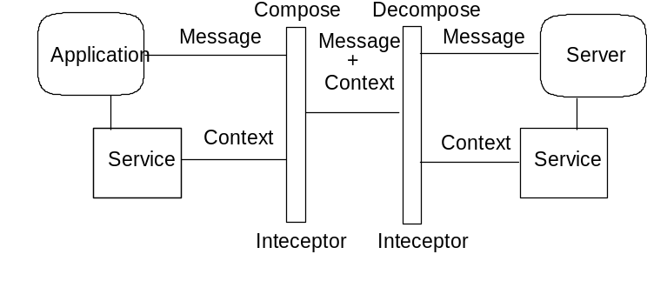
Figure 8: Services and context flow.
The context information is propagated to provide a flow of context information between distributed execution environments, for example using SOAP header information. This may occur transparently to the client and application services. The context may be propagated as part of normal message interchange within an application (e.g., as an additional part of the SOAP header) or may be sent as an explicit “out-of-band” context message, e.g., where the content of the message contains the context and a handle to link it to specific application messages which will be sent separately. Context propagation may also occur using different protocols than those used by the application. Therefore, JAXTX does not assume a specific means by which contexts are propagated, leaving this up to the specific coordination service implementation.
In those cases where existing XML-based transaction systems are being integrated into a JAXTX implementation, the context (and associated protocol) will typically already be defined. As mentioned previously, rather than insist that such systems be modified to work with JAXTX, there is no mandatory context defined by this specification. However, for new transaction implementations that address problems not provided for by existing implementations, JAXTX does provide an optional context format.

The Web Service
The Web Service, e.g., the taxi booking service. Whenever a user contacts a service whose work it wishes to be under the control of a transaction, components of the transaction system are responsible for flowing the context to that service. The service can then use this information to enlist a participant with the transaction. Note, in the rest of this document we shall use the term container when referring to the entity that is responsible for hosting a specific service, receiving requests for it, etc. This specification does not make any assumptions about the implementation of such a container and shall attempt to talk in terms of required functionality only. Note, a web service may also play the role of a participant.

The participant
The participant is the entity that actually does the real transaction work.
The Web Service (e.g., a theatre booking system) contains some business
logic for reserving a seat, enquiring availability etc, but it will need to
be back-ended by something that maintains information in a durable manner.
Typically this will be a database, but it could be a file system, NVRAM, etc.
Now, although the service may talk to the back-end database directly, it cannot commit or roll back any changes it (the
service) makes, since these are ultimately under the control of the
transaction that scoped the work. In order for the
transaction to be able to exercise this control, it must have some contact with the back-end resource (the database in our example) and this is accomplished by the
participant.
Each participant supports a termination protocol specific to the transaction model implemented by the coordinator (e.g., two-phase commit). In addition, the work that a participant performs when instructed by the coordinator that its transaction is terminating is dependant on its implementation (e.g., commit the reservation of the theatre ticket). The participant will then return an indication of whether or not it succeeded. Unlike in an ACID transaction model, some extended transaction models may allow participant implementations that do not have to guarantee that they can remain in a prepared state; an implementation may indicate that it can only do so for a specified period of time, and also indicate what action it will take (confirm or undo) if it has not been told how to finish before this period elapses.
As with the transaction context, JAXTX provides an optional protocol definition for coordinator-participant interactions.

The coordinator
Associated with every transaction is a coordinator, which is responsible for governing the outcome of the transaction. The coordinator may be implemented as a separate service or may be co-located with the user for improved performance. It communicates with enlisted participants to inform them of the desired termination requirements, i.e., whether they should accept (e.g., commit) or reject (e.g., roll back) the work done within the scope of the given transaction. For example, whether to purchase the (provisionally reserved) flight tickets for the user or to release them. This communication will be an implementation specific protocol (e.g., two or three phase completion).
A transaction manager is typically responsible for managing coordinators for many transactions. The initiator of the transaction (e.g., the client) communicates with a transaction manager and asks it to start a new transaction and associate a coordinator with the transaction. Once created the context can be propagated to Web Services in order for them to associate their work with the transaction.

The interfaces and protocols

Protocols
An application/client may wish to terminate a transaction in a number of different ways (e.g., commit or rollback). However, although the coordinator may attempt to terminate in a manner consistent with that desired by the client, it is ultimately the interactions between the coordinator and the participants that will determine the actual final outcome.
The context and coordinator-to-participant protocol are specific to the type of transaction model provided by the implementation. If an existing XML-based transaction service implementation is being integrated with JAXTS, then they will have a format that is specified in other protocol documents, e.g., BTP [ref]. It is not the domain of this specification to impinge on these protocols and require changes to them. As such, it is assumed that these will be specified elsewhere and relevant JAXTX component implementations will conform to them.
Although it is primarily expected that JAXTX will be used to provide a higher-level API for existing XML transaction implementations, this specification does provide its own optional XML-based protocol that may be used by designers when building new Web Service transaction models.

Interfaces
JAXTX defines both optional and mandatory interfaces. The mandatory interfaces can be categorised as follows:
- Client: these interfaces provide clients with a uniform means by which they may access and use client-specific functionality from different transaction implementations. These interfaces are designed to provide means whereby aspects of the underlying implementation may be accessed in a controlled manner.
- Implementation: the interfaces are for client-side extensions required for specific transaction models, e.g., BTP or JTA.
The optional interfaces are:
- Service: these interfaces provide services with a means by which they may access service-specific functionality from different transaction implementations. For example, a service provider may be able to support multiple different transaction protocols and use different participants for each; when the transaction implementation is imported by the service, it may determine the type of the transaction and act accordingly.

Combining implementations
Since we believe that there will be several different transaction implementations co-existing within the Web Services environment, it is logical to assume that some applications and services may require their use concurrently. As such, the JAXTX architecture does not place any limitations on the number of transaction implementations that may be utilised within a single application or JVM. Whether or not it makes sense for multiple implementations to co-exist, or for how they may inter-work (assuming inter-working is required) is beyond the scope of the JAXTX specification.

XML configuration
In order to select a specific transaction implementation for use, it is necessary to be able to define precisely the type of transaction service that is required. This must occur in an extensible manner that does not require changes to application code should the requirements or transaction definition change. As such, the use of XML is appropriate and JAXTS provides a transaction-definition schema.
Each implementer of a specific transaction service that can be accessed via JAXTX is required to define its characteristics using the JAXTX schema. These characteristics fall into two classes:
- Mandatory: this set of attributes is required to uniquely identify the type of transaction model supported by this implementation. Multiple implementations may support the same model and if differentiation is required based upon implementation specifics, then the optional fields may be used.
- Optional: the information maintained in these fields contains information that is not concerned with the specific model implemented by the service but which may still be relevant for users. For example, quality of service specifications (reliability requirements, performance guarantees), implementer details, etc.

Transaction configuration schema
The configuration portion of the transaction schema is shown below and described in the following section.
<?xml version="1.0" encoding="UTF-8"?>
<xsd:schema xmlns:xsd="http://www.w3.org/2001/XMLSchema" elementFormDefault="qualified">
<xsd:simpleType name="additional-information">
<xsd:restriction base="xsd:string"/>
</xsd:simpleType>
<xsd:complexType name="transaction-type">
<xsd:sequence>
<xsd:element name="transaction-name" type="xsd:anyURI"/>
<xsd:element name="transaction-type-specific-information" type="additional-information" minOccurs="0" maxOccurs="unbounded"/>
</xsd:sequence>
</xsd:complexType>
<xsd:element name="transaction-config">
<xsd:complexType>
<xsd:sequence>
<xsd:element name="tx-info" type="transaction-type" minOccurs="0" maxOccurs="1"/>
<xsd:element name="transaction-specific-information" type="additional-information" minOccurs="0"/>
</xsd:sequence>
</xsd:complexType>
</xsd:element>
</xsd:schema>
The transaction-config node allows a user to specify the characteristics it requires of a transaction service implementation and conversely for a transaction service implementation to define its own characteristics. The elements within this node are:
- tx-info: is an instance of the transaction-type and allows the unique name of the transaction to be set (transaction-name) via a URI. Additional information about the model implemented may be specified in string form via the transaction-type-specific-information element. How this information is specified and later interpreted is up to the transaction implementer to determine. Where this information is published in order for JAXTX implementations to bind to such transaction implementations is beyond the scope of this specification.
- transaction-specific-information: additional information about the non-functional aspects of the transaction implementation may be specified in this element. For example, performance characteristics, reliability metrics, etc. How this information is specified and later interpreted is up to the transaction implementer to determine. Where this information is published in order for JAXTX implementations to bind to such transaction implementations is beyond the scope of this specification.
For example, if we assume we have a transaction service implementation based on traditional two-phase commit, then the associated XML configuration might be:
<?xml version="1.0" encoding="ISO-8859-1"?>
<jaxtx:transaction-config xmlns:xsi="http://www.w3.org/2001/XMLSchema-instance" xmlns:jaxtx="http://someorg.org/schemas/JAXTX.xsd">
<jaxtx:tx-info>
<jaxtx:transaction-name>
urn:sun:transaction_models:presumed_above_two_phase_commit_no_heuristics
</jaxtx:transaction-name>
<jaxtx:transaction-type-specific-information>
99.99% availability
</jaxtx:transaction-type-specific-information>
<jaxtx:transaction-type-specific-information>
Implemented by John Doe of FooBar.com
</jaxtx:transaction-type-specific-information>
</jaxtx:tx-info>
</jaxtx:transaction-config>
In this configuration, the URI specifying the protocol indicates it is two-phase commit. However, there are various flavours of two-phase commit and the additional information fields specify attributes which can be used to refine the search for a specific transaction model.

JAXTX components

Features
The features provided by JAXTX to support the plugging of different transaction implementations within the architecture are described in this section, with reference to Figure 7.

Client interaction interface
Despite the variety of transaction implementations, the interfaces that most clients (and we include certain service-side interactions) use to interact with them are very similar. These typically involve: starting and ending a transaction (possibly terminating in multiple ways, e.g., commit or roll back), and associating/disassociating a transaction with/from the current thread of control. The UserTransaction is responsible for encapsulating this common functionality within a single interface. An implementation of the UserTransaction is responsible for mapping the JAXTX requirements to the underlying implementation. The UserTransaction then interacts with the coordinator service when instructed to by the client using whatever SOAP/XML protocol is required by the service implementation it encapsulates.
The client component of an application requires some means by which the transaction context is associated with any outgoing service invocation. As described earlier, the format of the context, where it occurs within an XML invocation document etc. will be specified by the appropriate implementation. The UserTransaction is required to encapsulate this context manipulation in a transparent manner to the client, such that as far as the client is concerned, the context flows implicitly with all relevant invocations.

Extended client interfaces
Some transaction implementations may require extensions to the general UserTransaction interface. For example, in the OASIS BTP there is scope for the client application to drive the two phase completion protocol explicitly, rather than leaving it to the coordinator as typically happens in other models. Thus, there is a requirement for more than simply telling the transaction coordinator to end.
In order to determine the properties of the underlying implementation, the UserTransaction configuration and properties are available in the form of a org.w3c.dom.Document. If the client requires access to protocol specific interfaces that the implementation supports, then it can either cast the underlying implementation to a well known interface (e.g., the interfaces specified in Section 6) or use reflection to obtain access to the extensions.

Coordinator interface
As far as a client is concerned, the coordinator is rarely seen as it is typically hidden behind interfaces such as UserTransaction. However, the service, or some entity acting on its behalf (e.g., a JDBC driver) will eventually be required to enrol participants with the coordinator (transaction) in order that it can ultimately control the fate of work conducted by the service within the scope of the transaction. As with the client, there are some similarities as to how a service or participant interacts with a transaction coordinator. However, this generality is on a much smaller scale than for the front-end client, typically involving only registering and un-registering participants, which will themselves be implementation specific. Therefore, rather than provide a basic, common interface through which only some interactions with the coordinator can occur, JAXTX does not provide any mandated standard coordinator interface. Implementations are free to provide their own interfaces/classes for services to use in order to access the necessary coordinator functionality. However, as we shall see, there is a Coordinator WSDL definition as part of the optional XML transaction protocol.

Participant interface
Section 3.1.3 described how a participant interface is typically specific to the transaction protocol in which it will be used. The coordinator-to-participant protocol is transaction model specific and leaves little room for generality. As such, there is no mandated participant interface as its value would be minimal at best. Therefore, as with coordinator interface, the participant WSDL interface provided by JAXTX is part of the optional protocol.

Context management
Figure 6 shows ho, both the client and the transactional Web Service will require context manipulation functionality. As illustrated in Figure 8, the context will typically be added to outgoing invocations at the client and removed at the service (perhaps by the container in which the service resides); what is done with the context at the service-side is not specified by JAXTX, but it will typically include some mechanism for associating the work that is about to be performed by the invocation with the transaction specified in the received context.
Normally the client and service do not need to see the format (implementation) of the context: the implementation is only of concern to those entities that are responsible for manipulating and using it. However, clients and services may need to be able to identify specific transactions or entire contexts without knowing how they are represented within the implementation. For example, some transaction implementations require that only a single participant be registered for each transaction; in order to do this, a service must be able to identify the transaction currently being imported. As such, JAXTX provides interfaces to allow clients and services to manipulate contexts at a suitably higher level.

Core JAXTX packages
The JAXTX specification defines several new javax packages, described briefly in the following sections and in more detail in the associated javadoc which accompanies this specification. The javax.jaxtx package contains interfaces and classes to which an implementer of JAXTX must conform. The javax.jaxtx.model.as, javax.jaxtx.model.jta and javax.jaxtx.model.btp contain implementation specific enhancements for transaction models conforming to the Activity Service [ref], JTA [ref] and BTP [ref] specifications respectively and will be described in Section 4.3.

javax.jaxtx package
The classes and interfaces of the javax.jaxtx, javax.jaxtx.exceptions, javax.jaxtx.completionstatus and javax.jaxtx.status packagse are required to abstract away from implementation specific details of the underlying transaction model, as illustrated in Figure 6. All classes provided by implementers will conform to one or more of these interfaces. These are summarized in this section and described in full in the accompanying javadoc.

CompletionStatus
The javax.jaxtx.completionstatus.CompletionSatus interface and associated classes define the basic modes in which a transaction can terminate.
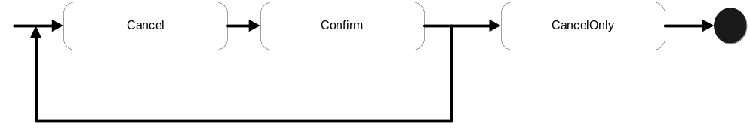
Figure 9: CompletionStatus state diagram.
As shown in Figure 9, at any time in its life a transaction can be in one of three completion states, to be described below, such that if it is asked to complete (explicitly by the user or implicitly by virtue of failures) it will do so in a manner prescribed by that state:
- ConfirmCompletionStatus: the transaction should complete in a successful state, i.e., all work performed within its scope should be accepted. Note, that if nesting of transactions is supported, this does not necessarily mean that any state changes are made permanent [moss]. When in this state, the transaction may be transitioned into any other state. Note, if the transaction cannot complete in this state then it will transition to the CANCEL state.
- CancelCompletionStatus: the transaction should complete in a failure state, i.e., all work performed within its scope should be undone in an implementation specific manner. When in this state, the transaction may be transitioned into any other state. This is the default completion state in which all transactions begin.
- CancelOnlyCompletionStatus: the transaction should complete in a failure state, i.e., all work performed within its scope should be undone in an implementation specific manner. Once in this state, the transaction state cannot transition any further.
Note, it is possible that a specific transaction model may have additional states in which is can complete, and these should be available to JAXTX users. Therefore, in order to ensure extensibility and that required state transitions do not conflict (e.g., state foo for one transaction model may mean something different for another), state types are specified as class implementations of the CompletionStatus interface and can therefore be augmented by implementations

Status
The state of a transaction at any point in its life is determined by the bStatus class and its associated implementations, as illustrated in Figure 10.
- ActiveStatus: the transaction initially starts in this state. An implementation returns this value prior to the coordinator entering a termination protocol or being marked as CancelOnly.
- MarkedCancelOnlyStatus: the transaction has been forced into a state whereby its eventual completion must be to cancel, i.e., CancelOnly.
- CompletingConfirmStatus: the transaction transitions to this state when told to complete and the completion status is Confirm. The transaction will remain in this state until it has completed in one termination outcome or another. If it cannot complete in the Confirm state then the transaction will transition to the Cancel state and complete. For example, in a two-phase completion protocol if the first phase (prepare) succeeds then the coordinator will commit (confirm) all state changes; if it fails then the coordinator will rollback (cancel) all state changes. If there are no failures, the transaction will typically remain in this state until it has received all responses to its termination protocol.
- CompletedConfirmStatus: the transaction has terminated successfully in the Confirm completion status. If this status is returned from a call to UserTransaction.status then it is likely that errors specific to the protocol exist (e.g., heuristics); otherwise the transaction would have been destroyed and NoTransactionStatus returned.
- CompletingCancelStatus: the transaction transitions to this state when told to complete and the completion status is Cancel. The transaction will remain in this state until it has completed.
- CompletedCancelStatus: the transaction has terminated successfully in the Cancel completion status.
- NoTransactionStatus: there is no transaction associated with the invoking thread.
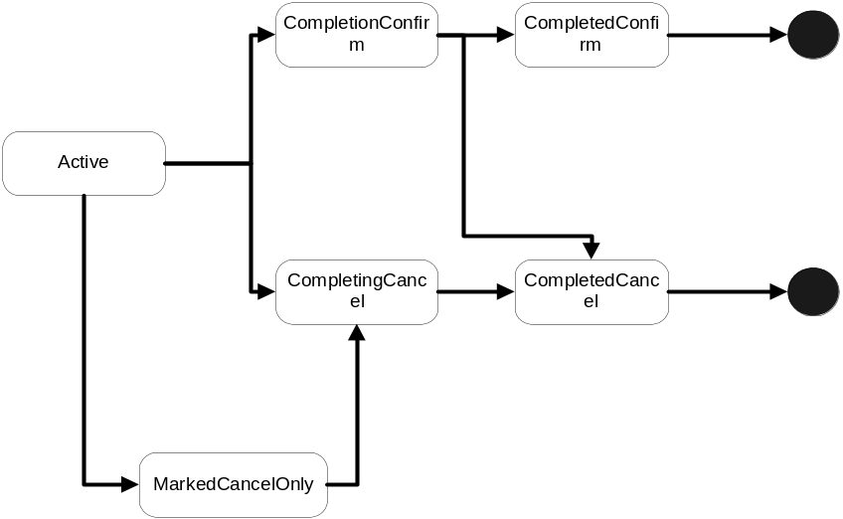
Figure 10: Transaction status transitions.
Note, it is possible that a specific transaction model may have additional states in which the transaction can be, and these should be available to users. Therefore, in order to ensure extensibility and that required state transitions do not conflict, state types are implementations of the Status interface and can be augmented by implementations.

Outcome
When a user informs a transaction to terminate, the act of termination may return information to the user. This information may be present both for successful and unsuccessful termination of a transaction. For example, in an implementation of the JTA protocol for Web Services, the ConfirmCompletionStatus state for a transaction would correspond to committing the transaction and a successful outcome to this would return no information. However, an unsuccessful termination, for example because of participant failures, could return a specific heuristic exception [jta].
In order to support the different transaction model requirements for return types, UserTransaction is required to return an instance of classes derived from the Outcome interface. The types of Outcome and their internal encoding are required to be specified by the definer/implementer of the transaction implementation.
The type of the transaction Outcome is obtainable from the name method, whereas the actual state in which it terminated is available from the completedStatus method; a user may want the transaction to complete in a ConfirmCompletionStatus state but the eventual outcome is determined by the coordinator and its participants such that failures or inabilities to complete the ConfirmCompletionStatus protocol may result in the transaction ending in a CancelCompletionStatus state.
Additional implementation specific data is made available in the form of an XML document (instance of org.w3c.dom.Document) through the data method. The user may obtain and parse this document to determine additional information on how the transaction terminated.

TxContext
TxContext is used as a representation of a transaction (or stack of transactions) when it is suspended from a running thread. The implementation of the token can be as lightweight as required by the underlying implementation in order that it can uniquely represent all transaction instances. Since this is a client-facing class, it is unlikely that the application user will typically want to see the entire transaction context in order to simply suspend it from the thread.

UserTransaction
The UserTransaction is the interface that most users (e.g., clients and services) will see. This isolates them from underlying protocol specific aspects of the transaction implementation they are using. If required, an underlying implementation may provide additional methods to users, who may cast or reflect to the underlying implementation if necessary. Importantly, a UserTransaction does not represent a specific transaction, but rather is responsible for providing access to an implicit per-thread transaction context; it is similar to the UserTransaction in the JTA specification [ref]. Therefore, all of the UserTransaction methods implicitly act on the current thread of control.
Fundamental to the JAXTX architecture is the notion of a transaction context. As illustrated in Figure 12, each thread is associated with a context via UserTransaction. This association may be null, indicating that the thread has no associated transaction, or it refers to a specific transaction. Contexts may be shared across multiple threads. In the presence of nested transactions a context remembers the stack of transactions started within the environment such that when the nested transaction ends the context of the thread can be restored to that in effect before the nested transaction was started.
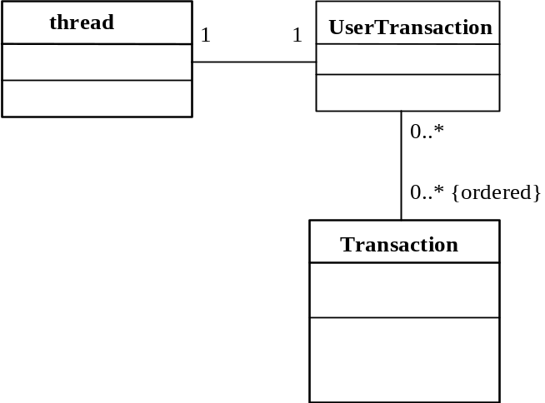
Figure 11: Thread and context relationship.

A new transaction is begun and associated with the invoking thread by using the start method. A transaction that is already associated with the invoking thread will become the parent of this newly created transaction, i.e., the new child transaction is nested within the parent. If nesting is not supported or available (e.g., the implementation reaches a nesting limit imposed by the transaction model being used), then the javax.jaxtx.exceptions.NestingNotAllowedException is thrown. The state of the parent transaction may be such that it is invalid for a new transaction to be created within its scope (e.g., the parent is in the process of terminating) and in this situation the javax.jaxtx.exceptions.InvalidStateException is thrown.
The setTimeout method modifies a state variable associated with the UserTransaction that affects the time-out period in seconds associated with the transaction created by subsequent invocations of the start method. If parameter has a non-zero value and the transaction has not begun to terminate before this time period has elapsed, it will be completed in the CancelCompletionStatus mode. If the timeout period is invalid or not supported, then the javax.jaxtx.exceptions.InvalidTimeoutException is thrown. A value of zero means that no application specified time-out is established. This is the default value associated with all using threads.
The getTimeout method returns the timeout value currently associated with the UserTransaction.
The state in which the current transaction should be completed is set using the setCompletionStatus method and passing in either one of the CompletionStatus defined types or one specific to the model being used. If the completion state is invalid given the state of the transaction (e.g., it has already begun to complete) then the javax.jaxtx.exceptions.InvalidStateException will be thrown. The completion status of the transaction currently associated with the invoking thread can be obtained from the getCompletionStatus method. As shown in Figure 9, if there has been no call to the setCompletionStatus then the default completion status is CancelCompletionStatus. If there is no transaction associated with the current thread then the javax.jaxtx.exceptions.NoTransactionException is thrown by both methods.
A transaction can be told to complete using the end method, which will also disassociate the thread from the transaction. The completion status the transaction implementation uses will either have been set by a previous call to setCompletionStatus, may be provided as a parameter to end, or will be the default of CancelCompletionStatus. If this is a top-level transaction, i.e., it has no parent, then upon completion the thread will have no transaction associated with it. If no transaction is associated with the current thread then the javax.jaxtx.exceptions.NoTransactionException is thrown.
Some transaction models may restrict the ability for threads to end transactions, e.g., such that only the transaction creator may terminate the transaction (c.f. checked transactions in the OTS). If this is the case, the implementation will throw the javax.jaxtx.exceptions.NoPermissionException. If the specified completion state of the transaction is not compatible with the transaction’s state (for example, its completion state is CancelOnlyCompletionStatus and the user has asked the transaction to terminate with a status of CompletionStatus.SUCCESS), or the state of the transaction does not allow it to be terminated, then the javax.jaxtx.exceptions.InvalidStateException will be thrown.
Obviously a transaction may not be able to complete in the state originally requested by the user. When the transaction terminates it may return an Outcome object to indicate how it did complete. It is valid for end to return a null Outcome. A transaction that completes and does not return an Outcome or throw an exception is assumed to have completed successfully in the manner requested.
A thread of control may require periods of non-transactionality so that it may perform work that is not associated with a specific transaction. In order to do this it is necessary to disassociate the thread from any transactions. The suspend method accomplishes this, returning a TxContext instance, which is a handle on the transaction. If the current transaction is nested, then the TxContext will implicitly represent the stack of transactions up to and including the root transaction. The thread then becomes associated with no transaction.
The resume method can be used to (re-)associate a thread with a transaction(s) via its TxContext. Prior to association, the thread is disassociated with any transaction(s) with which it may be currently associated. If the TxContext is null, then the thread is associated with no transaction. The javax.jaxtx.exceptionsInvalidTransactionException is thrown if the transaction that the TxContext refers to is invalid in the scope of the invoking thread. Obviously the validity or not will be dependant on the underlying transaction implementation to determine.
The getTransactionContext method returns the TxContext for the current transaction, or null if there is none. Unlike suspend, this method does not disassociate the current thread from the transaction(s). This can be used to enable multiple threads to execute within the scope of the same transaction.
The current status of the transaction is returned by the status method. If there is no transaction associated with the thread then NoTransactionStatus is returned. It is possible that the exact determination of a transaction’s status is not possible when status is invoked and in which case UnknownStatus is returned. This is a transient value and calling status again will eventually return the transaction’s status.
Every transaction is required to have a unique identity, which can be obtained from the globalIdentity method. However, in order to ensure that transaction identifiers are unique across all transaction models, the value returned by globalIdentity is required to be prefixed with the package name of the transaction implementation. For example, “javax.jaxtx.1234” or “javax.jaxtx.jta.1234”. If there is no transaction associated with the current thread then null will be returned.
In addition to globalIdentity, the transactionName method can be used to obtain a more user-friendly representation of the transaction. This may return the same as globalIdentity or more return other information more suitable for debugging purposes, for example. If there is no transaction associated with the current thread then null will be returned.
The parent of the current transaction is returned by getParent. If the current transaction has no parent, i.e., is a top-level transaction, then null is returned. If there is no transaction associated with the invoking thread then the javax.jaxtx.exceptions.NoTransactionException is thrown.

UserTransactionFactory
UserTransactions are obtained from a UserTransactionFactory, which is made available via JNDI lookup of java:comp/UserXMLTransactionFactory. The UserTransaction corresponding to the specific transaction type is returned from the factory’s getTransactionType method, as defined in the associated XML document configuration. If no such transaction type is provided by the factory, then the javax.jaxtx.exceptions.NoSuchServiceException is thrown. Alternatively, all of the transaction types supported by the factory may be returned through the getAllTransactionTypes method. The factory may restrict the accessibility for clients to obtain all transaction types through this method and throw the javax.jaxtx.exceptions.InvalidSecurityOptionException.

Model bindings
In the following sections we shall examine how specific transaction models may be mapped into a JAXTX environment.

The Business Transactions Protocol
In this section we shall examine the extensions to the basic JAXTX interfaces to provide support for the OASIS Business Transactions Protocol (BTP).
An actor within the coordinating entity’s system plays the role of Superior and an actor within the system of the party plays the role of an Inferior. Each Inferior has only one Superior. However, a single Superior may have multiple Inferiors within each or multiple parties. A tree of such relationships may be wide, deep, or both as shown in Figure 13.
An Inferior is associated with some set of application activities that create effects within the party. Usually, this will be a result of some operation invocations (on a “service application element”) from elsewhere (an “initiating application element”). The Inferior is responsible for reporting that it is “prepared” for the outcome to the Superior whether or not the associated operations’ provisional effect can be confirmed or cancelled.
A Superior receives reports from its Inferiors as to whether they are “prepared” to give an outcome. It gathers these reports in order to determine which Inferiors should be cancelled and which confirmed. The Superior does this either by itself or with the cooperation of the application element responsible for its creation and control, depending upon whether the transaction is an atom or a cohesion as we shall see later.
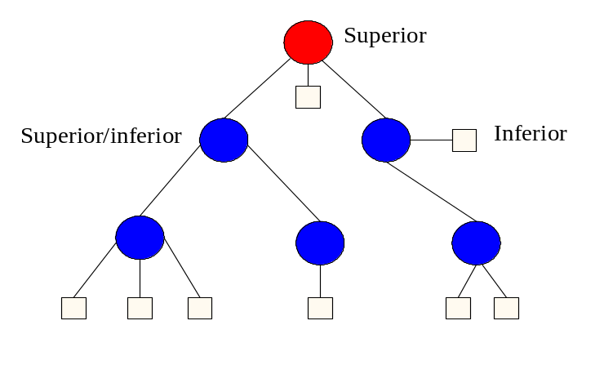
Figure 13: Transaction Relationships

Client-side interfaces
The classes and interfaces described in this section are located within the javax.jaxtx.models.btp package. The OASIS BTP defines two types of extended transactions:
- Atom: an atom is the typical way in which “transactional” work performed on Web services is scoped. The outcome of an atom is guaranteed to be atomic, such that all enlisted participants (acting on behalf of their associated Web services) will see the same outcome, which will either be to accept (confirm) the work or reject (cancel) it.
- Cohesion: this type of transaction was introduced in order to relax atomicity and allow for the selection of work to be confirmed or cancelled based on higher level business rules. Atoms are the typical participants within a cohesion but, unlike an atom, a cohesion may give different outcomes to its participants such that some of them may confirm whilst the remainder cancel. In essence, the two-phase protocol for a cohesion is parameterised to allow a user to specify precisely which participants to prepare and which to cancel. The strategy underpinning cohesions is that they better model long-running business activities, where services enrol in atoms that represent specific units of work and as the business activity progresses, it may encounter conditions that allow it to cancel or prepare these units, with the caveat that it may be many hours or days before the cohesion arrives at its confirm-set: the set of participants that it requires to confirm in order for it to successfully terminate the business activity. Once the confirm-set has been determined, the cohesion collapses down to being an atom: all members of the confirm-set will see the same outcome.
In a traditional transaction system, the application has very few verbs with which to control transactions. Typically these are “begin”, “commit” and “rollback”. When an application asks for a transaction to commit, the coordinator will execute the entire two-phase protocol before returning an outcome (what BTP terms a closed-top commit protocol). The elapse time between the execution of the first phase and the second phase is typically milliseconds to seconds.
However, the two-phase algorithm does not impose any restrictions on the time between executing the first and second phases. Clearly the longer the period between first and second phases, the greater the chance for failures to occur and the longer resources remain locked. BTP allows the time between the two phases to be set by the application by expanding the range of verbs available to include explicit control over both phases, i.e., “prepare”, “confirm” and “cancel”; what BTP terms an open-top completion protocol. The application has complete control over when transactions prepare, and using use whatever business logic is required later determine which transactions to confirm or cancel.
Therefore, although both atoms and cohesions can be terminated in a traditional “closed-top” manner, it is more typical for the two-phase completion protocol to be driven explicitly. As such, the javax.jaxtx.models.btp.Atom and javax.jaxtx.models.btp.Cohesion exist to extend the default UserTransaction interface.
Instances of the javax.jaxtx.models.btp.Vote interface are returned from the Atom when it is instructed to prepare. An atom (and implicitly its participants) can return one of the following votes as a result:
- VoteCancel: the inferior votes that it has cancelled. The transaction service may inform the inferior of the final decision (hopefully to cancel as well), but it need not.
- VoteConfirm: the inferior votes to confirm. It will typically not have confirmed at this stage but will wait for the transaction outcome. Failure to do so may result in heuristics (contradictions).
- VoteResign: the inferior votes that all of its inferiors have resigned from the transaction. The transaction (atom) is terminated.
When a javax.jaxtx.models.btp.Cohesion is instructed to prepare, cancel or confirm its enlisted participants (inferiors), it may return a status value for each of them. It does this through the javax.jaxtx.models.btp.StatusItem interface. The status is a value from the javax.jaxtx.models.btp.TwoPhaseOutcome enumeration.

Service-side interfaces
The classes and interfaces described in this section are for the optional service-side interactions and are located in the javax.jaxtx.models.btp.opt package.
A BTP superior (e.g., instance on which participants may enrol) is represented by an instance of the Superior interface. Each participant within a BTP transaction is represented by the Inferior interface. This has methods for preparing, confirming and cancelling the participant as well as obtaining its current status. As shown previously, a superior may be an inferior in some distributed hierarchy. The root superior is known as the decider and is represented by the Decider interface.
Services can enrol participants through the TransactionManager interface, which returns a reference to the current transaction (Superior) via the getTransaction method. The Transaction interface provides a means whereby Inferiors may be enrolled with a specific transaction. Unlike UserTransaction, a Transaction does represent a specific transaction.
An Inferior is enrolled with a transaction using the enrol method; if the transaction is not in a state where enrolment is possible (e.g., it is terminating) then the javax.jaxtx.exceptions.WrongStateException will be thrown. If the Inferior has already been enrolled with this transaction then the javax.jaxtx.models.btp.DuplicateInferiorException is thrown and the Inferior will not be enrolled with the transaction.
BTP allows for an enrolled Inferior to leave a transaction. This may be accomplished through the resign method. If the coordinator is not in a state where leaving is validthen the javax.jaxtx.exceptions.WrongStateException is thrown. If the Inferior is invalid within the context of the transaction (e.g., it has not been enrolled) then the javax.jaxtx.models.btp.opt.InvalidInferiorException will be thrown.

As shown in Figure 14, it is the service container’s responsibility to ensure that any imported transaction context is made available to the service via the TransactionManager implementation. In the figure, a client begins a new transaction via UserTransaction.begin() and then invokes a method (foo) on the remote service. The request, along with the transaction context, is transmitted between the client and the service using a protocol specific to the application environment (e.g., SOAP over HTTP).
In a typical transactional application implementation, the incoming service request is intercepted (e.g., by the service container or interceptor), the context is stripped off and a proxy for the imported transaction is created; this proxy is then associated with the thread of control that performs the actual work. Other protocol specific work may also be performed, such as registering a participant or performing interposition [ref].
In a JAXTX environment, all of the above work is obviously performed within the implementation specific layer. The JAXTX implementation of TransactionManager is required to utilise this layer in order to be able to present the service with a representation of the current transaction when, and if, required. Note, this may simply be a reference to the original (imported) transaction.
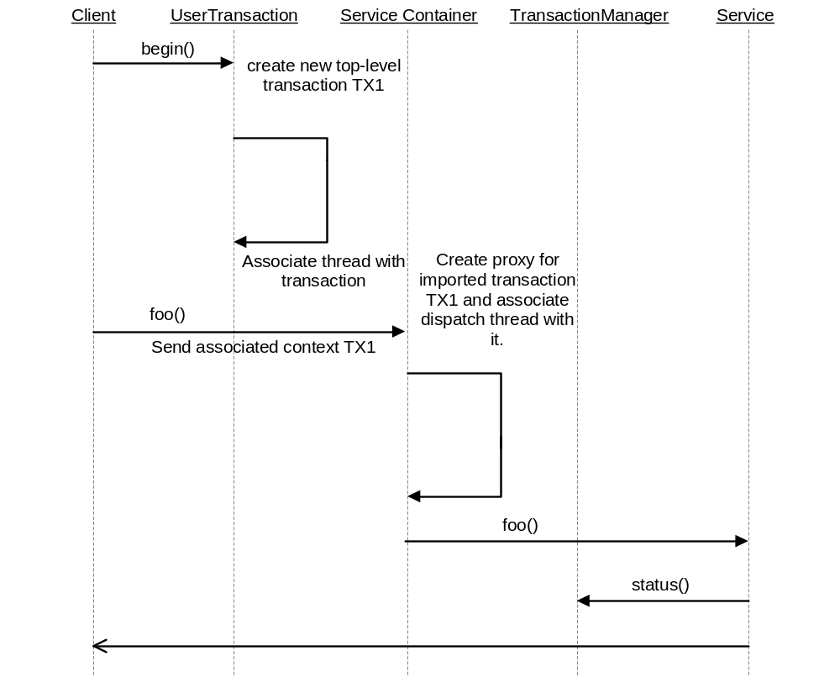
Figure 14: Containers and imported transactions.

Transaction framework protocol
In this section we shall describe the optional XML protocol that JAXTX provides (JAXTXP) for new transaction service implementations. Note, this protocol is optional and an implementation of JAXTX is free to choose which (if any) components it wishes to support.
Section 2.2 described how a single (extended) transaction protocol is unlikely to be suitable for all problem domains: one-size does not fit all. Each extended transaction protocol is designed to target a specific problem area, e.g., relaxing atomicity or allowing controlled un-serialisable behaviour. Therefore, rather than specify an XML-based transaction protocol that is aimed at solving a single problem, the optional JAXTX protocol is deliberately meant to allow arbitrary transaction implementations to utilise it; in essence this is a framework for supporting many different transaction protocols. The goals of this protocol are therefore to:
- Provide a basic definition of a core transaction service consisting of a Coordinator Service. The protocol that this service uses will be hidden behind the interface (WSDL).
- Define the required infrastructure support, such as event mechanisms, etc.
- Define the roles and responsibilities of subcomponents.
The main components involved in using and defining the protocol are:
- A Coordination Service: defines the behaviour of a specific transaction model and provides a processing pattern that is used for outcome determination. For example, a two-phase ACID transaction service is one implementation whose processing sequence includes prepare, commit and rollback. Other implementation examples include Sages, Collaborations and Real-Time transactions.
- A Participant: The operation or operations that are performed as part of coordination sequence processing when triggered by the Coordination Service. During the lifetime of a transaction, a coordinator may send many different XML messages to a participant, which may perform specific units of work depending upon how it interprets these XML messages. Note, an implementation of a participant could be a coordinator, forming a distributed tree structure, with root and sub coordinators.
- The context: this contains information necessary to perform coordination as well as information specific to the Coordination Service.
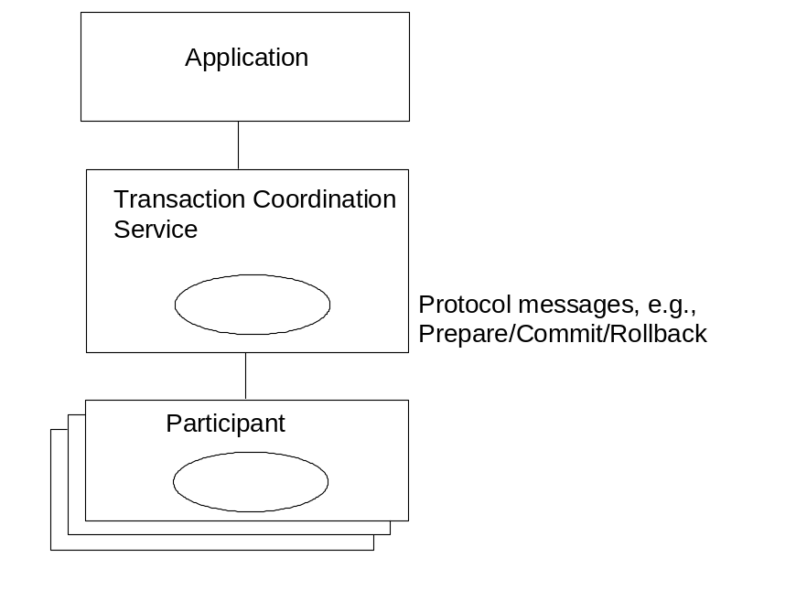
Figure 15: Coordination Service and action relationship.

Qualifiers
In order to be flexible and cope with a wide range of extended transaction models, it is necessary to support controlled extensibility of the XML message-set provided by JAXTXP. The Qualifier concept is a means whereby implementation specific caveats or data may be applied to protocol messages. The format of the Qualifier is shown below:
<xsd:element name="qualifier">
<xsd:annotation>
<xsd:documentation>
qualifier represents a component of the sequence of qualifiers.
</xsd:documentation>
</xsd:annotation>
<xsd:complexType>
<xsd:attribute name="name" use="required">
<xsd:annotation>
<xsd:documentation>
Attribute describes name element of qualifier name-value pair.
</xsd:documentation>
</xsd:annotation>
</xsd:attribute>
<xsd:attribute name="value" use="required">
<xsd:annotation>
<xsd:documentation>
Attribute describes value element of qualifier name-value pair.
</xsd:documentation>
</xsd:annotation>
</xsd:attribute>
</xsd:complexType>
</xsd:element>
<xsd:element name="qualifiers">
<xsd:annotation>
<xsd:documentation>
qualifiers represents values for qualifiers name-value pairs.
</xsd:documentation>
</xsd:annotation>
<xsd:complexType>
<xsd:sequence>
<xsd:element ref="qualifier"
maxOccurs="unbounded"/>
</xsd:sequence>
</xsd:complexType>
</xsd:element>
A qualifier is a name/value tuple-space, with qualifiers being an arbitrary sized list of these tuple-spaces. Each specific transaction implementation must define which qualifiers it accepts and enforce rules associated with them.

Protocol messages
In Section 2 we saw the relationship between the transaction coordinator and participants. This relationship exists irrespective of the type of transaction protocol that is being used: at some point (or points) during the lifetime of the transaction, the coordinator will be required to communicate with the participants. Likewise, a service or participant may be required to communicate with the coordinator.
For example, the termination of one activity may initiate the start/restart of other activities in a workflow-like environment. Messages can be used to infer a flow of control during the execution of an application. The information encoded within a Message will depend upon the implementation of the extended transaction model and is allowed to be any arbitrary information.
A participant will use the message in a manner specific to the transaction implementation and return a result of it having done so. For example, upon receipt of a specific message, a participant could start another transaction running (e.g., a compensation transaction); another participant could commit any modifications to a database when it receives one type of message, or undo them if it receives another type.
JAXTXP does not require that communication between coordinator and participant be synchronous or based on any request/response pattern. Message exchanges may occur in an RPC-based approach if deemed necessary by the transaction implementation, or it may be more asynchronous, message-based. As a result, a participant may send responses to coordinator messages that have not yet been (and potentially may never be) produced, e.g., a two-phase participant may be able to autonomously prepare itself and signal this fact to the coordinator, even though the coordinator may never be asked to commit.
In addition, as we shall see in Section 5.1.4, unlike traditional ACID two-phase protocols, where a user’s (direct or indirect) interaction with the coordinator signals the end of the transaction, this is not an assumption JAXTXP makes: coordinator interactions may occur at many times during the lifetime of a transaction.
<xsd:element name="protocol_message" substitutionGroup="message">
<xsd:complexType>
<xsd:sequence>
<xsd:element name="specific_data" type="xsd:anyType" minOccurs="0" maxOccurs="unbounded"/>
<xsd:elememt ref=”qualifiers” minOccurs=”0”/>
</xsd:sequence>
<xsd:attribute name="identification" type="xsd:anyURI" use="required"/>
<xsd:attribute name="related_to" type="xsd:anyURI" use="optional"/>
</xsd:complexType>
</xsd:element>
- identification: this is the unique identification of this message and will be interpreted by the receiver in a protocol specific manner. For example, the two-phase commit transaction identified by the “urn:twophase” may define protocol messages “urn:twophase:prepare”, “urn:twophase:commit” and “urn:twophase:rollback”, which would be interpreted by receivers as either preparing, committing or rolling back the transaction accordingly. Their responses may be “urn:twophase:readonly”, “urn:twophase:ok” and “urn:twophase:fail”.
- specific_data: additional protocol-specific information may be present in this field.
- qualifiers: any qualifiers necessary for the interpretation of this message are specified in this field.
- related_to: JAXTXP does not require that coordinator-to-participant interactions be synchronous and driven by the coordinator. As such, it is entirely possible that a participant may autonomously decide to send the coordinator a message to indicate its current state in the protocol. For example, a two-phase aware participant may be able to spontaneously prepare and send the result to the coordinator, on the assumption that the coordinator will eventually send it a prepare message. If the participant does, however, it is important that it also specify which message it assumed the coordinator would generate in order for it to send that response: if the coordinator does not eventually send that message then obviously the response from the participant is in error. As such, the related_to field is required to be present for all spontaneously generated participant responses and indicates the relevant coordinator protocol message. It is optional in all other message interactions.

More on context
The context information is propagated using SOAP messages, and is correlated to the application messages using unique identifiers in the SOAP header. The context may be propagated as part of normal message interchange within an application (e.g., as an additional part of the SOAP header) or may be sent as an explicit “out-of-band” context message, e.g., where the content of the message contains the context and a handle to link it to specific application messages which will be sent separately. Context propagation may also occur using different protocols than those used by the application. Therefore, JAXTXP does not assume a specific means by which contexts are propagated, leaving this up to the specific coordination service implementation.
<xsd:element name="contextelement">
<xsd:annotation>
<xsd:documentation>
contextelement represents the information for an entry in the hierarchy.
</xsd:documentation>
</xsd:annotation>
<xsd:complexType>
<xsd:attribute name="transaction-name" type="xsd:anyURI" use="optional"/>
<xsd:attribute name="coordinator" type="Coordinator" use="required"/>
<xsd:attribute name="ctxId" type="xsd:anyURI" use="required"/>
<xsd:attribute name="timeout" type="xsd:integer" use="optional"/>
<xsd:attribute name="implementation_specific_data" type="xsd:anyType" use="optional"/>
<xsd:sequence>
<xsd:element ref="qualifiers" minOccurs="0"/>
</xsd:sequence>
</xsd:complexType>
</xsd:element>
<xsd:element name="context" substitutionGroup="message">
<xsd:annotation>
<xsd:documentation>
context represents the context hierarchy.
</xsd:documentation>
</xsd:annotation>
<xsd:complexType>
<xsd:sequence>
<xsd:element ref="contextelement"/>
</xsd:sequence>
<xsd:attribute name="invocation_specific_data" type="xsd:anyType" use="optional"/>
</xsd:complexType>
</xsd:element>
In order to support nesting of transactions, the context is an arbitrary length sequence of contextelement data structures, where the first element in the list is the root transaction and the last is the current transaction. The data encoded within this structure is:
- transaction-name: an optional unique name for this transaction, this field may be used to identify the type of transaction being imported.
- coordinator: a reference to the coordinator responsible for this specific transaction. See Section 5.1.4 for more information about the coordinator.
- ctxId: a unique identifier for this transaction.
- timeout: some transaction implementations allow a timeout value (typically measured in seconds) to be associated with a transaction, such that, if the transaction has not been completed when this time elapses, it will be automatically terminated.
- implementation_specific_data: any additional information which may be required by the specific transaction implementation being used. How this is identified and interpreted is outside the scope of this specification.
- qualifiers: additional qualifiers that may be required to further interpret the information contained within the context.

Coordinator
To drive the message exchanges a coordinator is associated with each transaction. Activities that require to be informed when coordinator sends a specific message can register a participant with that coordinator. When a message is sent by the coordinator (e.g., at termination time), it may result in a response being returned by the recipient (participant). Alternatively, depending upon the protocol in use, no such message may be forthcoming. As such, the coordinator-participant interaction is not required to be synchronous and follows a more asynchronous, message-oriented pattern. However, synchronous, RPC-based invocations, may be layered on top of this.
In a traditional ACID transaction system, the two-phase protocol is only executed by the coordinator when the transaction terminates. Once the second phase has completed successfully, the transaction and associated coordinator are terminated. However, there are several extended transaction models that allow coordination to occur at times during the lifetime of the transaction (e.g., Split Transactions [ref]). Therefore, the JAXTX coordinator can be driven at arbitrary points.
The implementation of the coordinator will obviously depend upon the type of extended transaction model being used. For example, if a Sagas type model is in use then a compensation message may be required to be sent to participants if a failure has happened, whereas a coordinator for a strict transactional model may require to send a message informing participants to rollback.
The accompanying WSDL for the coordinator shows it to have the following methods:
- complete_transaction: this instructs the coordinator to terminate the transaction in the state specified.

Participant

References

Atomic, Consistent, Isolated, Durable.
Do we want to specify that some fields are optional for matches whereas others are mandatory? Or are they all optional and anything that is really required must be in the URI?
Who maintains the URNs for different transaction protocols?

